U.S. CUSTOMS AND BORDER PROTECTION
LABORATORY METHODS
CBPL METHOD 04-27
Analysis of Buffalo and Bovine Mozzarella Cheese Mixtures
by Polyacrylamide Gel Isoelectric Focusing

SAFETY STATEMENT
This CBPL Method cannot fully address safety issues that may arise from its use. The analyst is responsible for assessing potential safety issues associated with a given method at its point of use.
Before using this method, the analyst will consider all general laboratory safety precautions. In particular, the analyst will identify and implement suitable health and safety measures and will comply with all pertinent regulations.
METHOD UNCERTAINTY
The uncertainty of measurement for this method is specific to each laboratory.
0. SCOPE AND FIELD OF APPLICATION
This separation technique utilizes a dry isoelectric focusing (IEF) PhastGel™ with the PhastSystem™ apparatus (Pharmacia-LKB Biotechnology) to distinguish mozzarella cheese derived from water buffalo milk and bovine milk. The technique is useful for establishing the authenticity of a water buffalo cheese, provided for in Chapter 4 of the Harmonized Tariff Schedule of the United States (HTSUS), and allows semiquantitative determination of mixtures of the two animal sources.
1. PRINCIPLE
Base-soluble proteins are concentrated and isolated from the cheese matrix. Treatment with the enzyme plasmin converts the beta caseins to gamma caseins, greatly enhancing their naturally low concentration. The gamma caseins of the two species have different isoelectric points, which allow the differentiation to be made by the IEF gel electrophoresis procedure.
By preparing known mixtures of the dried isolated proteins, estimation of bovine milk content in water buffalo cheese can be achieved to as low as 2 percent (w/w).
2. REFERENCES
2.1 Addeo, F., Moio L., Chianese L., and Nota G. “Evaluation of Bovine and Water Buffalo Milk in Mixtures of Liquid Milk and Mozzarella Cheese by Gel Isoelectric Focusing.” Italian Journal of Food Science. 3, 71-80. 1989.
2.2 Moio, L., Chianese L., and Addeo F. “Use of PhastGel™ Dry IEF for Rapid Detection of Bovine Milk in Ovine, Caprine, and Water Buffalo Milk or Cheese.” Application Note 374. Amersham Biosciences (Pharmacia). 1998. [Copies available online at Amersham Biosciences web site.]
2.3 Trieu-Cuot, P., Addeo F. J. Dairy Research. 48, 311. 1981.
2.4 Trieu-Cuot, P., Gripon C. J. Dairy Research. 48, 303. 1981.
3. APPARATUS
3.1 PhastSystem™ apparatus (Pharmacia- LKB Biotechnology).
3.2 Dry gel reconstituting cassette.
3.3 Sample applicators [(8/1); 8 lanes/ 1μL delivered].
3.4 Dry IEF gels (Pharmacia).
3.5 Centrifuge capable of spinning at 3000 RPM.
3.6 Analytical balance (± 0.0001 g).
3.7 Mortar and pestle.
3.8 Vortex mixer.
3.9 Screw-capped culture tubes (16 mm x 100 mm, 16mm x 125 mm).
3.10 37°C water bath.
3.11 Erlenmeyer flasks (125 mL or larger).
3.12 Pasteur pipettes.
3.13 Magnetic stirrer.
3.14 Automatic pipettes covering 1-1000 μL.
3.15 Disposable pipette tips covering 1-1000 μL.
3.16 Micro centrifuge tubes.
3.17 Syringe, approximately 3 cc capacity.

4. REAGENTS
4.1 Deionized water (18 megohm-cm minimum purity).
4.2 Plasmin Suspension (Boehringer Mannheim, bovine origin).
4.3 Trichloroacetic acid (TCA), ACS reagent.
4.4 Sodium tetraborate (anhydrous or decahydrate), ACS Reagent.
4.5 Ampholine, pH 5-7 (Pharmacia).
4.6 Pharmalyte, pH 6.7-7.7 (Pharmacia).
4.7 Urea, ACS Reagent.
4.8 Glacial acetic acid, ACS Reagent.
4.9 95 percent (v/v) Ethanol, ACS Reagent.
4.10 Petroleum Ether, ACS Reagent, bp 36-60°C.
5. MATERIALS AND SOLUTIONS
5.1 pH Indicator papers, pH range 0 to 14.
5.2 Hydrophilic membrane filters (0.45 μm pores, nylon or cellulose acetate membrane), syringe-style.
5.3 50-mM sodium tetraborate buffer: Add 10.06 g of granular anhydrous sodium tetraborate or 19.07 g of sodium tetraborate decahydrate to 1000 mL of deionized water. Stir to dissolve. The solution pH should be between 9.0 - 9.5.
5.4 8 M urea-borate buffer: Dissolve 9.600 grams urea and 0.2012 grams sodium tetraborate in deionized water in a graduated Erlenmeyer flask to obtain 20 mL solution. This solution should be prepared daily as needed.
5.5 7.8 M urea: Dissolve 4.68 grams urea in deionized water in a graduated Erlenmeyer flask to obtain 10 mL solution. This solution should be prepared daily as needed.
5.6 24 percent (w/w) TCA solution: Add 12 g of TCA to 38 mL deionized water in a 125 mL Erlenmeyer flask.
5.7 20 percent (w/w) TCA solution: Add 10 g of TCA to 40 mL deionized water in a 125 mL Erlenmeyer flask.
5.8 1:1 (v/v) Petroleum Ether/Water: Mix equal volumes of petroleum ether and deionized water.
5.9 PhastGel™ Silver Kit, #17-0617-01 (Pharmacia)
5.10 Rehydration solution for the PhastGel™ dry IEF: Prepare a solution by mixing 3.6 mL of 7.8 M urea, 0.2 mL Ampholine pH 5-7, and 0.2 mL of Pharmalyte pH 6.7-7.7.
6. REFERENCE SAMPLES
6.1 Fresh mozzarella cheese (water buffalo) from a known source
6.2 Fresh mozzarella cheese (bovine) from a known source
7. TEST SAMPLES
7.1 A fresh cheese sample should be obtained and kept refrigerated. The sample should be frozen, if the sample cannot be analyzed within two weeks. Samples that are stored for long periods of time should always be stored in a frozen state.
8. PROCEDURE
8.1 Weigh a 1 to 2 gram sample of cheese to ±0.01 g.
8.2 Homogenize the sample in 10.0 mL of 50 mM sodium tetraborate buffer (pH 9.0 to 9.5). Transfer the solution to a screw cap culture tube (16 mm x 125 mm).
8.3 Vortex the solution and allow it to stand 5 minutes.
8.4 Centrifuge the sample at 3000 RPM (minimum) at room temperature for 10 minutes.
8.5 Transfer 1.5 mL of the fat-free portion of the supernatant solution to a preweighed culture tube (16 mm x 100 mm).
8.6 Add 25 μL (or sufficient volume to supply 0.125 Units) of plasmin (Boehringer Mannheim bovine origin)
8.7 Incubate for 1 hour at 37°C in a water bath.
8.8 Precipitate the proteins by adding 1.5 mL of 24 percent (m/m) TCA and vortex for 30 seconds.
8.9 Centrifuge at 3000 RPM (minimum) for 10 minutes at room temperature. Discard the supernatant.
8.10 Wash the precipitate with 10 mL of a 1:1 (v/v) petroleum ether/deionized water solution. Wash the precipitate again with 10 mL of deionized water. Mixing is achieved by vortexing for 30 seconds. Centrifuge at 3000 RPM (minimum) for 10 minutes at room temperature. Discard the supernatant after each wash.
8.11 For a qualitative species determination, this precipitate, the wet weight sample, can be analyzed by proceeding to 8.14.
8.12 If the analysis is to continue on the next day, invert the tube in a tube rack, and allow the precipitate, the protein pellet, to air-dry overnight. This provides the dry weight sample, which is suitable for a semiquantitative determination.
8.13 Reweigh the test tube with the sample in it and calculate the weight of the protein sample.
8.14 Solubilize the sample with sufficient volume of 8 M urea-borate buffer solution to achieve a final concentration of 2 percent (v/v) for the dry weight sample or 10 percent (v/v) for the wet weight sample. If the sample is turbid, filter through a small pore (0.45 μm) hydrophillic membrane filter.
8.15 Rehydrate the PhastGel™ dry IEF in a PhastGel™ cassette according to the instructions provided with the cassette kit and Pharmacia Application Note 374.
8.16 Apply 1 μL of the sample to the anode side of the gel according to the procedure in the PhastSystem™ user manual using the PhastGel™ 8/1 applicator.
8.17 The electrophoresis program for the separation of the proteins is as follows: Sample Applicator down at 1.2 0 Vh
Sample Applicator up at 1.2 15 Vh
Sep 1.1 1200V 2 mA 2.5W 15C 75 Vh
Sep 1.2 200V 2 mA 2.5W 15C 15 Vh
Sep 1.3 1200V 5 mA 2.5W 15C 710Vh
8.18 The gel is stained and fixed according to the directions enclosed with the PhastGel™ Silver Staining Kit.
8.19 The gel either should be mounted in plastic, or a picture should be taken of the gel, for the permanent record.
9. RESULTS
An example of the type of results that can be obtained can be seen in Figure 1. The semiquantitative determination for a cheese prepared from a mixture of the two milk sources requires comparison to appropriate mixtures of solutions of the pure proteins similarly isolated from authentic bovine and water buffalo milk cheeses.

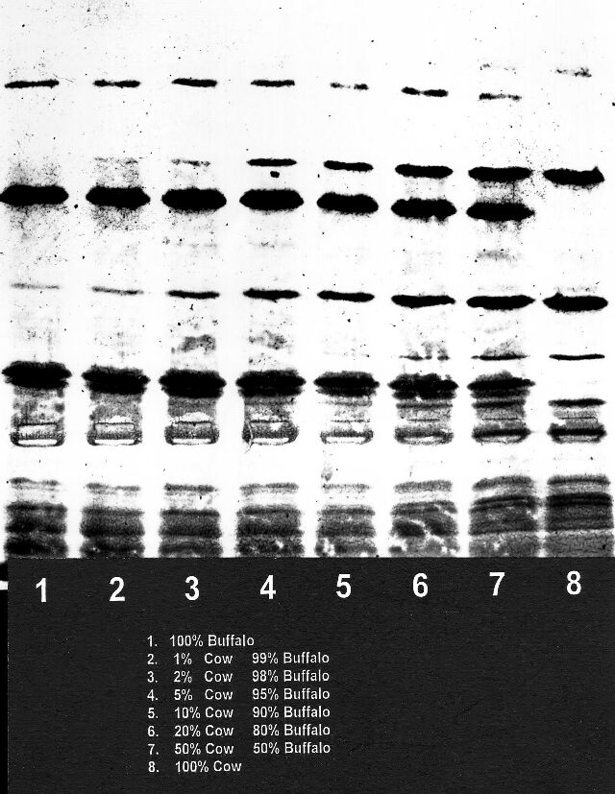

Figure 1
END

