U.S. CUSTOMS AND BORDER PROTECTION

LABORATORY METHODS

CBPL METHOD 11-06

The Identification of Wheat Gluten

by Reversed-Phase HPLC

SAFETY STATEMENT
This CBPL Method cannot fully address safety issues that may arise from its use. The analyst is responsible for assessing potential safety issues associated with a given method at its point of use.
Before using this method, the analyst will consider all general laboratory safety precautions. In particular, the analyst will identify and implement suitable health and safety measures and will comply with all pertinent regulations.
METHOD UNCERTAINTY
The uncertainty of measurement for this method is specific to each laboratory.
0. SCOPE AND FIELD OF APPLICATION
This separation technique utilizes reversed-phase high-performance liquid chromatography to identify the presence of wheat gluten, which is provided for in Chapter 11 of the Harmonized Tariff Schedule of the United States (HTSUS). The technique is useful for distinguishing wheat gluten from other cereal proteins, viz. those obtained from barley, corn, oat, brown rice, and rye.

1. PRINCIPLE
The major storage proteins of wheat (gliadins) are effectively extracted in a 70% ethanol solution. The prepared sample is then injected onto a reversed-phase (C4) column, and eluted with an acetonitrile/H₂O gradient. Different wheat gluten varieties produce slightly different peak profiles.
The peak profiles from other types of cereal grain can easily be distinguished from those of wheat gluten. The amount of protein in the 70% alcohol extract (optimum extraction conditions for wheat gliadins) of wheat gluten is also much greater than the amount found in other cereal grains.

2. REFERENCES
2.1 Bietz, J.A., Burnouf, T., and Wall, J.S. Cereal Chemistry 61:124-129. 1984.
2.2 Bietz, J.A. and Huebner, F.R. in Identification of Food-Grain Varieties (C.W. Wrigley, editor). AACC. St. Paul, MN. Pp. 73-78. 1995.
2.3 Huebner, F.R. and Bietz, J.A.. in High-Performance Liquid Chromatography of Cereal and Legume Proteins (J.E. Kruger and J.A. Bietz, Editors). AACC. St. Paul, MN. Pp. 206-221. 1994.
2.4 Ram C., Huebner, F.R. and Bietz, J.A. Seed Science and Technology. 23:259-262. 1995.
3. APPARATUS
3.1 Shimadzu HPLC with a photodiode array detector or equivalent
3.2 Column heater capable of heating column to 58 °C.
3.3 C4 VYDAC 300 Angstrom column 250 x 4.6mm).
3.4 VYDAC High Performance Guard column Holder (Manufacturer catalog number 214GK54) and Guard Cartridges (Manufacturer number 214GD54) or equivalent
3.5 Analytical balance (±0.001g).
3.6 Vortex mixer.
3.7 Two 1 or 2 liter solvent holding bottles.
3.8 Erlenmeyer flasks (1L).
3.9 Graduated cylinder (500 mL).
3.10 Auto sampler vials with caps.
3.11 Suitable disposable culture tubes.
3.12 Syringe, approximately 3mL.
4. REAGENTS, MATERIALS, AND SOLUTIONS
4.1 Reagents:
4.1.1 Deionized water (18 megohm-cm minimum purity).
4.1.2 Trifluoroacetic Acid (TFA) in 1 mL ampoules (Sigma).
4.1.3 Acetonitrile, ACS Reagent.
4.1.4 Ethanol, ACS Reagent.
4.1.5 Centrifuge capable of 3000 rpm.
4.2 Materials and Solutions:
4.2.1 Hydrophilic membrane filters (0.45 μm pores, nylon or cellulose acetate membrane), syringe style.
4.2.2 20% (v/v) acetonitrile solution A. Add 200 mL of acetonitrile to 800 mL of deionized water and mix thoroughly. Break open the 1 mL vial of TFA and add it to the solution.
4.2.3 80% (v/v) acetonitrile solution B. Add 800 mL of acetonitrile to 200 mL of deionized water and mix thoroughly. Break open another 1mL vial of TFA and add it to the solution.
4.3 References Controls:
4.3.1 Wheat gluten, barley, rye, oat, corn, and rice flour from known source.

5. PROCEDURE
5.1 Weigh 500 mg of a well-mixed gluten flour control into one test tube and 500 mg of wheat flour sample into another test tube. Weigh 2500 mg into a test tube for all other cereal samples.
5.2 Add 10 mL of a 70% ethanol solution and vortex for 1 minute.
5.3 Let the test tubes stand for 1 minute.
5.4 Filter sample solutions through a 0.45-μm membrane into a sample vial.
5.5 If sample cannot be filtered, then centrifuge sample at 3000 rpm for 10 minutes.
5.6 Set column temperature at 58 °C.
5.7 Set the detector to 220 nm.
5.8 The HPLC gradient program for the separation of the proteins starts at 20% B and increases linearly to 45% B over a period of 50 minutes. It then increases from 45% B to 100% B over the next 10 minutes. It then drops to 20% B over the next 5 minutes. The recorded run time is 60 minutes and the flow rate is 1 mL per minute. The column should equilibrate about 10 minutes between runs.
5.9 Inject 10 μL of a wheat gluten control or 25 μL of the wheat flour sample or other cereal samples onto the column.

6. RESULTS
6.1 For an example of the kind of results that can be obtained, see Figure 1. Samples that are wheat gluten should give a similar peak profile. Peak profiles of the other cereal grains (25% solutions with 25 μL injected) are shown in Figures 2 to 6.

7. NOTE
7.1 The non-vital denatured wheat gluten peak profile will contain predominately non-distinct peaks but will have the same characteristic wheat gluten double peak at approximately 35 and 36 minutes. (See Figure 7)

Figure 1
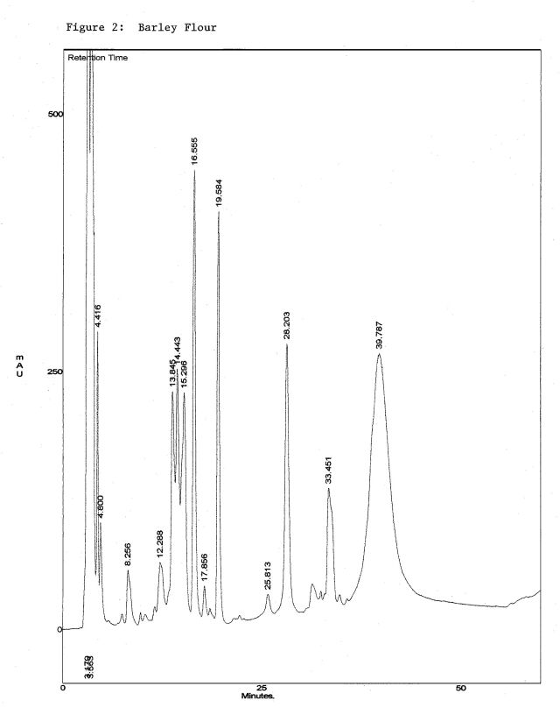
Figure 2
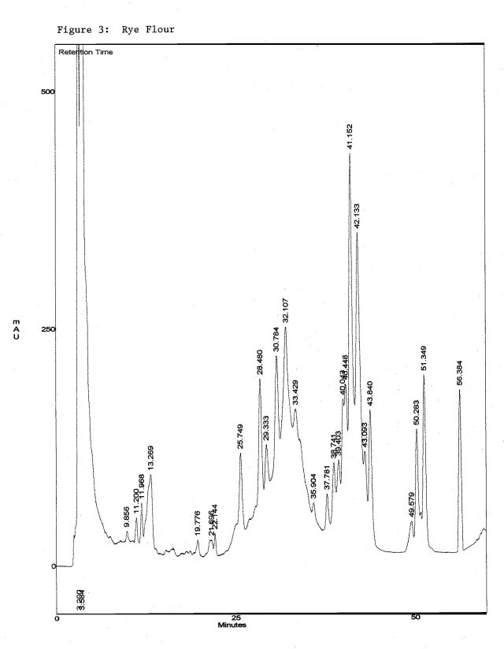
Figure 3
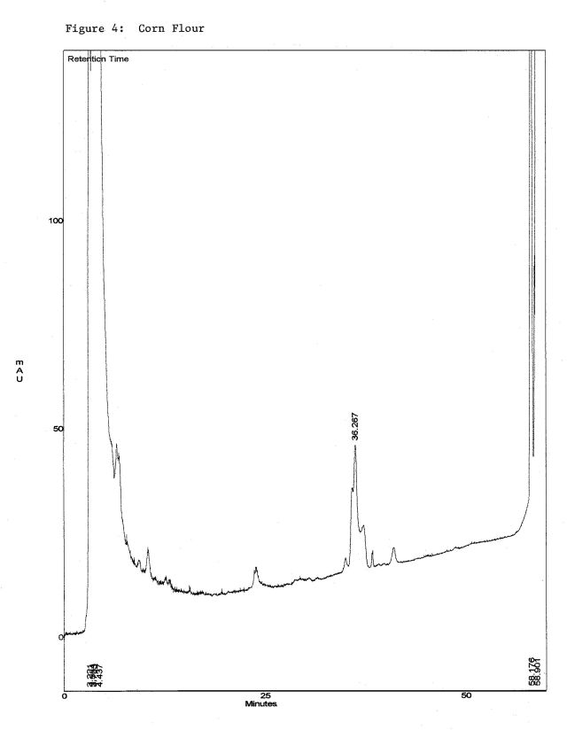
Figure 4
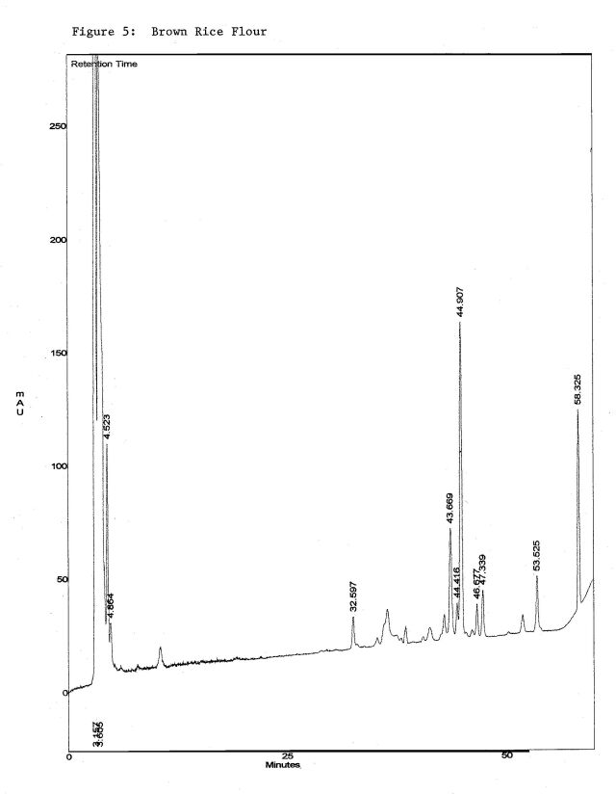
Figure 5
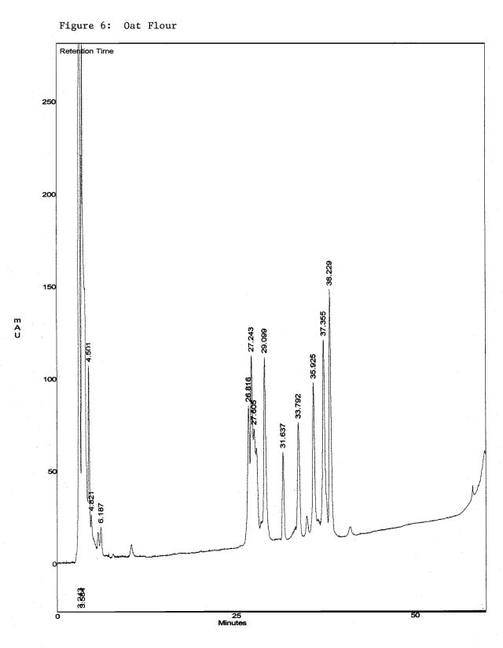
Figure 6
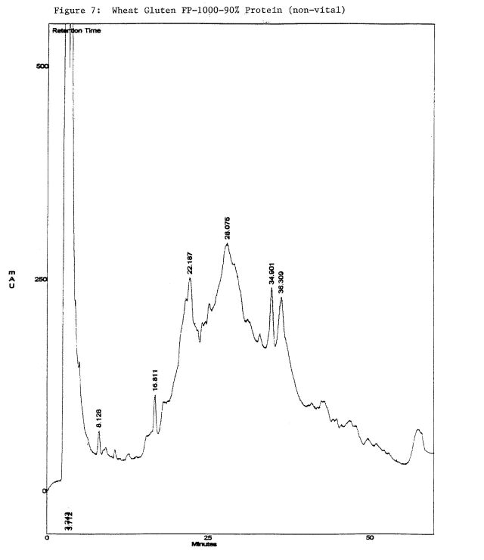
Figure 7
END

