US CUSTOMS AND BORDER PROTECTION
LABORATORY METHODS
CBPL 34-11
Quantitative Analysis of Palm Oil Acid Wax and Qualitative
Screening of Wax Mixtures by Capillary Gas Chromatography

SAFETY STATEMENT
This CBPL Method cannot fully address safety issues that may arise from its use. The analyst is responsible for assessing potential safety issues associated with a given method at its point of use.
Before using this method, the analyst will consider all general laboratory safety precautions. In particular, the analyst will identify and implement suitable health and safety measures and will comply with all pertinent regulations.
METHOD UNCERTAINTY
The uncertainty of measurement for this method is specific to each laboratory.
0. INTRODUCTION
This method is based on established scientific principles of gas chromatography (GC) and provides for the qualitative identification of wax type and quantitative measurement of acid wax in candles containing petroleum (paraffin-type) wax. Sample chromatograms of the most common pure wax types are included (Figures 6.4.4 and 6.4.5/6).
Samples are first screened by infrared (IR) spectroscopy and GC to ensure that they fall within the scope of this method. A carbonyl band at ~1700 cm⁻¹ in the sample IR spectrum indicates the presence of acid wax. A carbonyl band at ~1740 cm⁻¹, whether alone or in combination with a 1700 cm⁻¹ band, indicates the presence of ester wax.
For GC quantification, fatty acid components of acid wax are derivatized by any suitable silylation reagent, such as bis(trimethylsilyl)-acetamide (BSA), and the sample is quantitatively analyzed on a gas chromatograph equipped with a flame-ionization detector (GC-FID). A reference mixture containing acid wax and paraffin wax is prepared and analyzed to generate a calibration table for the acid components. The response factor for all peaks is set to 1, and a normalized area percent report is generated. The total percent paraffin (%HC_{t}) present in the sample is assumed to be 100% minus the total percent acid wax (%AW) from the normalized area percent report. Temperature-programmed, cool-on-column injection is used to avoid inlet discrimination of high boiling components.
1. SCOPE AND FIELD OF APPLICATION
Wax candles are classifiable in Chapter 34 of the Harmonized Tariff Schedule of the United States (HTSUS), Heading 3406. This method applies to candles containing petroleum wax admixed with any acid wax with composition similar to palm oil acid wax and allows quantification of the acid wax and paraffin wax components. The quantitative part of this method is not applicable to any ester wax, whether or not admixed with palm acid wax and/or paraffin.
2. REFERENCES
2.1 ASTM D 5442 “Standard Test Method for Analysis of Petroleum Waxes by Gas Chromatography.”
2.2 CBPL 34-10/ASTM E 1252 “Standard Practice for General Techniques for Obtaining Infrared Spectra for Qualitative Analysis.”
2.3 NHM 012 (working number for draft document, 1995; previously NHM007-1995P). “Gas Chromatography Method for the Analysis of Waxes,” [Project 10062-MD, developed by Canada Customs Lab by Lay-Keow Ng, Diann Whitehead, and Chad Dalton.]
2.4 CBPL 34-15. “Qualitative Analysis of Wax and Gel Candles by Infrared Spectroscopy.”
3. DEFINITION OF TERMS
3.1 Paraffin: aliphatic hydrocarbons characterized by a straight or branched carbon chain with generic formula C_{n}H_{2n+2}, where n is an integer.
3.2 Petroleum Wax: for the purpose of this method only, petroleum wax is defined as paraffin-type wax derived from petroleum.
3.3 Petroleum-Derived Hydrocarbon: for the purpose of this method only, petroleum-derived hydrocarbon is defined as paraffin-type hydrocarbon derived from petroleum.
3.4 Vegetable Wax: wax obtained from plant origin.
3.5 Palm Oil-Derived Vegetable Wax: wax derived from the oil of the palm plant, Elaeis guineensis.
3.6 Acid Wax: a wax composed of long-chain fatty acids.
4. REAGENTS AND apparatus
Unless otherwise stated, all reagents are of technical grade or better.
4.1 Any suitable solvent for dissolving wax and wax acids such as CCl₄ or toluene.
4.2 Reference wax as specified by CBPL or otherwise composed of approximately 50:50 w/w of paraffin wax and acid wax mixture:
4.2.1 Paraffin wax, approximate mp 53-57 °C, CAS 8002-74-2, Aldrich Chemical Co. or equivalent.
4.2.2 Acid wax mixture composed of the following acids in percent by weight (exact weight percent, %AW_{RA}, in reference mixture must be known):
4.2.2.1 0.2% Dodecanoic (C12) acid;
4.2.2.2 1.4% Tetradecanoic (C14) acid;
4.2.2.3 59% Palmitic (C16) acid;
4.2.2.4 0.1% Heptadecanoic (C17) acid;
4.2.2.5 39% Stearic (C18) acid;
4.2.2.6 0.3% Eicosanoic (C20) acid.
4.3 Authentic reference wax such as palm wax or beeswax, as applicable and if available.
4.4 Analytical balance.
4.5 Glass or polypropylene jars.
4.6 Drying oven, preferably with air exchange, capable of maintaining 105±5 °C.
4.7 Disposable aluminum (Al) pans, ~25 mL and larger capacity.
4.8 Glass vials and beakers, 20 mL.
4.9 BSA or other suitable silylation (TMS) reagent.
4.10 GC autosampler vials and caps.
4.11 GC-FID with cool-on-column (COC) inlet, electronic flow control, autosampler, and automated peak integration software, such as Agilent® 6890 with Chemstation® software.
4.12 He carrier gas, 99.995% minimum purity; high-purity hydrogen may also be used.
4.13 Compressed air and hydrogen.
4.14 High-temperature coated capillary column capable of complete resolution of all target analytes, such as Restek ® MXT-1, 6m x 0.53mm x 0.15μm.
4.15 5-μL autosampler syringe with a 23-26-gauge needle for COC injector.
4.16 IR spectrometer.
5. HOMOGENIZATION OF SAMPLE AND REFERENCE MATERIALS
5.1 In a 105 °C oven or a boiling water bath, melt the entire candle or reference wax in an appropriate container (e.g., glass for oven and polypropylene for water bath) that is at least twice the sample volume. For candles made of wax poured into a non-wax container, the entire candle may be melted in its original container then poured into a container twice the sample volume.
5.2 Stir the melt until completely homogenized.
5.3 Pour ~10 mL into a 20-mL vial and ~5 mL into a 25-mL Al pan, and allow wax to cool completely.
5.4 Break wax in Al pan into small pieces for analysis.
NOTE: Use of Al pans to facilitate representative sub-sampling is consistent with ASTM D 5442. The wax remaining in the 20-mL vial may be remelted and sampled for additional analysis as needed.
6. PROCEDURE
6.1 Perform IR qualitative screening using CBPL 34-15 (2.4).
6.2 Perform GC qualitative screening by weighing ~10 mg homogenized sample wax in ~2 mL hot solvent. Transfer to GC vial, and make a single injection using parameters listed in 6.5.1 through 6.5.7. Use reference chromatograms provided to determine the types of waxes present in the sample.
6.3 Preparation of quantitative analytical solutions.
NOTE: To avoid degradation of moisture-sensitive silylation reagents, all glassware used to prepare analytical solutions must be dry. Glassware may be dried in 105 °C oven overnight and cooled prior to use.
NOTE: Because quantification is based on normalized area percent, samples need not be weighed exactly.
6.3.1 Sample wax solution (SS, ~5 mg/mL): Weigh ~10 mg homogenized sample wax from 5.4 into a small beaker. (Alternatively, using a glass stir rod, a drop of melted, homogenized wax from 5.2 may be sampled directly into a beaker and prepared as follows.) Dissolve completely in ~1 mL hot solvent. Add ~1 mL BSA, mix thoroughly, transfer into a GC vial, and cap vial. Heat vial at 80 °C for at least 15 min to derivatize acid components. Prepare in duplicate to make SS1 and SS2.
6.3.2 Reference wax solution (RS, ~5 mg/mL): Repeat 6.3.1 using homogenized reference wax from 4.2 instead of sample wax to make RS.
6.3.3 For those samples containing pure paraffin or pure palm acid wax as indicated by IR results, prepare only one analytical solution for each sample wax and reference wax mixture, and make only one GC injection per solution to verify IR results.
6.4 Initial GC method setup.
To be done once at initial method setup or when a new or different column is installed to obtain retention times for acid wax components and to verify that all target peaks are adequately resolved.
6.4.1 Prepare a solution containing ~5 mg/ml fatty acid wax mixture in ratio 1:1:58:1:38:1 of C12:C14:C16:C17:C18:C20 dissolved in an equal mixture of solvent and BSA.
6.4.2 Prepare a solution containing ~5 mg/mL paraffin wax (4.2.1) dissolved in an equal mixture of solvent and BSA.
6.4.3 Make single injections of each solution from above using GC parameters from 6.5.
6.4.4 Overlay acid and paraffin wax chromatograms to verify complete resolution of major components (Fig. 6.4.4). Adjust GC parameters and rerun acid and paraffin wax references as necessary to ensure peak resolution.
6.4.5 Create a temporary calibration table and a compound group (Fig. 6.4.5/6) containing all acid wax components.
6.4.6 Set the response factor for all calibrated (acid wax) and uncalibrated (paraffin) peaks to 1 (Fig. 6.4.5/6).
6.5 GC quantification.
Use the following as a guide to set up GC run conditions. Parameters may be adjusted as necessary (such as when using a column other than that specified in 4.14) to achieve complete resolution of all target analytes.
6.5.1 Injector temperature: 100 °C, ramped 30 °C/min to 300 °C.
6.5.2 Detector temperature: 380 °C.
6.5.3 Oven temperature program: 70 °C (1 minute), ramp 25 °C/min to 360 °C, final hold time 0-3.5 min (increase hold time as needed to prevent carryover).
6.5.4 Carrier gas flow: 8.0 mL/min, constant flow mode.
6.5.5 Injection volume: 0.5 μL.
6.5.6 Injection mode: cool-on-column.
6.5.7 Syringe rinse solvent: same as sample solvent (equivalent to at least four rinses on Agilent® 6890).
6.5.8 Integrator OFF: 0.0 min.
6.5.9 Adjust “Integrator” ON, “Area Reject,” “Height Reject,” and “Slope Sensitivity” as necessary to ensure that all acid wax and paraffin peaks are integrated but not solvent or residual TMS reagent peaks.
6.5.10 Make duplicate injections of each solution (single injections for solvent blank) in the following order:
6.5.10.1 Solvent blank
6.5.10.2 RS (6.3.2)
6.5.10.3 SS1 (6.3.1)**
6.5.10.4 SS2 (6.3.1)**
6.5.10.5 Solvent blank**
6.5.10.6 RS (6.3.2)**
NOTE: Repeat ** marked steps as necessary when analyzing multiple candle samples.
7. EXPRESSION OF RESULTS
7.1 Update the calibration table using results from first RS injection, remembering to set response factor for all peaks to 1 and adjusting settings (6.5.9) as necessary to ensure integration of all acid wax and paraffin peaks.
7.2 Generate “Normalized Area Percent” reports for all reference and sample runs.
7.3 Average results for all reference (RS) runs to get experimental percent acid wax in reference, %AW_{RE}.
7.4 Average duplicate injections for each sample duplicate (SS1 and SS2) to obtain experimental percent acid wax in sample, %AW_{SE}.
7.5 Calculate correction factor (CF):
$$\text{CF}=\frac{\text{\%}{\text{AW}}_{\text{RA}}}{\text{\%}{\text{AW}}_{\text{RE}}}$$
7.6 Calculate actual %AW in sample:
$$\text{\%} {\text{AW}}_{\text{SA}}=\text{\%} {\text{AW}}_{\text{SE}} x \text{CF}$$
7.7 Calculate percent hydrocarbon added to sample:
$$\text{\%} {\text{HC}}_{t}=\text{100} \text{\%}−\text{\%} {\text{AW}}_{\text{SA}}$$
7.8 Duplicate injections for each solution must be within ±0.5% of each other, or the injections are repeated. Average duplicate samples, and record results to the nearest 0.1%. Duplicate values for a sample must fall within ±2% of the average value.
7.9 Samples containing paraffin wax within +10% of antidumping cutoff values must be analyzed by another quantitative method such as SPE to verify paraffin wax content.
8. Example Calculations
8.1 A reference acid wax mixture (4.2.2) is prepared with the following composition:
Acid Component | Mass used (mg) | % w/w in mixture
C12 | 11.0 | 0.2%
C14 | 71.4 | 1.4%
C16 | 3008.4 | 58.8%
C17 | 5.0 | 0.1%
C18 | 2006.2 | 39.2%
C20 | 16.6 | 0.3%

8.2 A reference acid-paraffin wax mixture (4.2) is prepared with the following composition:
Ref Component | Mass used (mg) | % w/w in mixture
Paraffin (4.2.1) | 2000.9 | 49.6%
Acid mix (8.1) | 2030.4 | 50.4%
8.3 Averaged “Normalized Area Percent” report for the acid-paraffin reference mixture gives a value of 46.3% for the acid components (%AW_{RE} = 46.3%).
8.4 $\text{CF}=\frac{\text{50}\text{.}4\text{\%}}{\text{46}\text{.}3\text{\%}}=1\text{.}\text{09}$
8.5 Injection-averaged “Normalized Area Percent” report for sample gives:
%AW_{SE1} = 24.6% and %AW_{SE2} = 25.0% for sample duplicates 1 and 2, respectively.
8.6 Actual percent acid wax in sample is %AW_{SA1} = 24.6% X 1.09 = 26.8% and %AW_{SA2} = 27.2% (sample average = 27.0%)
8.7 Percent hydrocarbon added to sample is %HC_{t} = 100% - 27.0% = 73.0%
9. Test Report
9.1 Report results according to agency policy.
10. BIBLIOGRAPHY
This list is provided for general guidance and should not be considered exhaustive. The user is expected to seek current references pertaining to this method.
10.1 Bennett, H. (Editor). Industrial Waxes, Volume I. “Natural and Synthetic Waxes.” Chemical Publishing Co. New York. 1975.
10.2 Chromatography, Fifth Edition, Part A: Fundamentals of Chromatography. Journal of Chromatography Library. 1982.
10.3 Encyclopedia of Chemical Technology, Third Edition, Volume 24. Wiley-Interscience. New York. 1984.
10.4 Kolattukudy, P.E. (Editor). Chemistry and Biochemistry of Natural Waxes. Elsevier. Amsterdam, The Netherlands. 1976.
10.5 Shahidi, F. (Editor). Bailey’s Industrial Oil and Fat Products, Sixth Edition. Volume 2: “Edible Oil and Fat Products: Edible Oils,” Part 1. John Wiley & Son. Hoboken, NJ. 2005.

Figure 6.4.4. GC chromatogram (a) during initial method setup to verify adequate resolution of major components and (b) for quantitative reference wax mixture in 4.2.
(a)
(b)
Figure 6.4.5/6. Example of calibration table settings when using Agilent® Chemstation® software. Retention times were obtained using column specified in 4.14 and GC run parameters specified in 6.5.
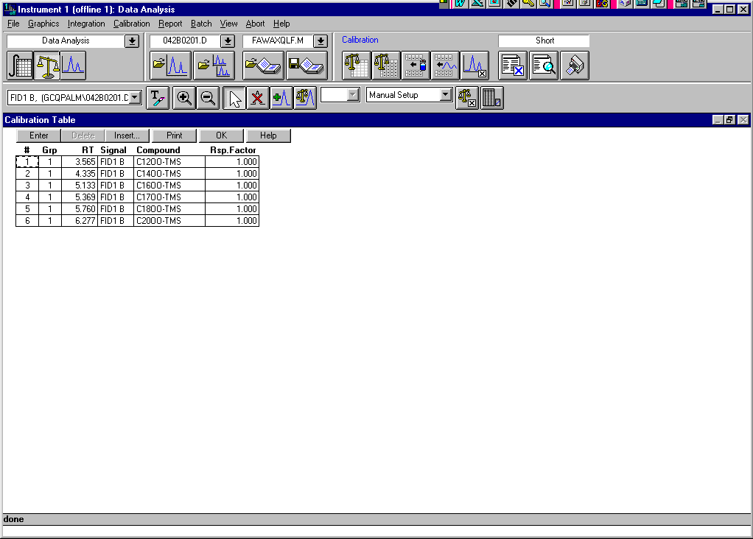
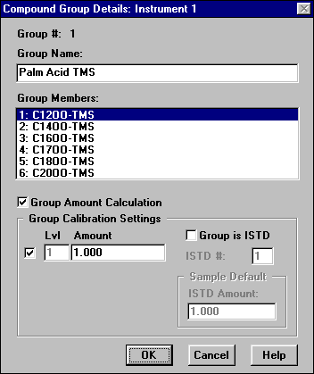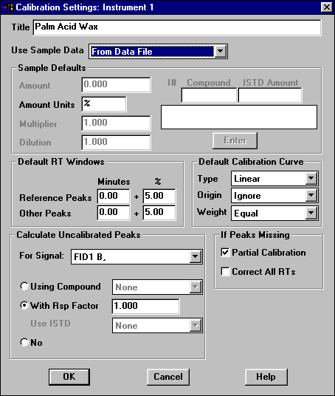
Figure 6.4.5/6 (continued.). Qualitative chromatograms of underivatized solutions using column specified in 4.14 and GC run parameters specified in 6.5: (a) palm acid wax; (b) palm ester wax. Also, see samples (c) and (d) on page 10.
(a) (b)
Figure 6.4.5/6 (continued). Qualitative chromatograms of underivatized solutions using column specified in 4.14 and GC run parameters specified in 6.5: (c) white beeswax; (d) soy wax. Also, see samples, (a) and (b), page 9.
(c)
(d)
END

